Exp.No-5

5. Perform basic Image Handling and processing operations on the image
• Read an image in python and Erode an Image using erode function.

Aim:
To perform image erosion using OpenCV.

Procedure:
- Start the program.
- Import OpenCV and NumPy.
- Read the input image.
- Create a kernel matrix.
- Apply the erosion operation.
- Display the original and eroded images.
- Save the eroded image.
- Stop the program.
Program:
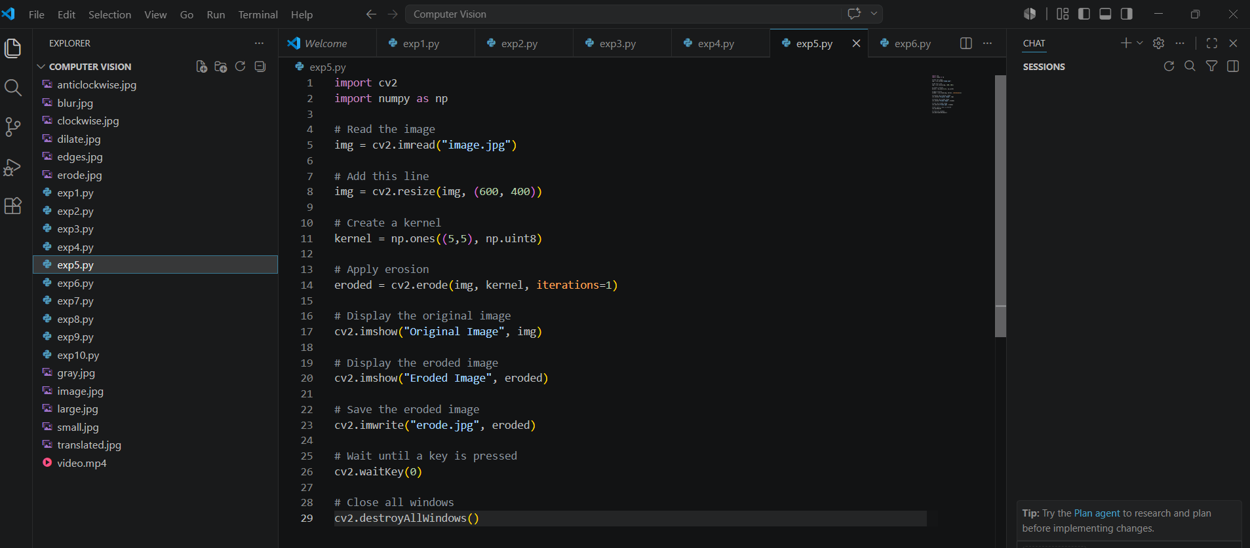

Input:
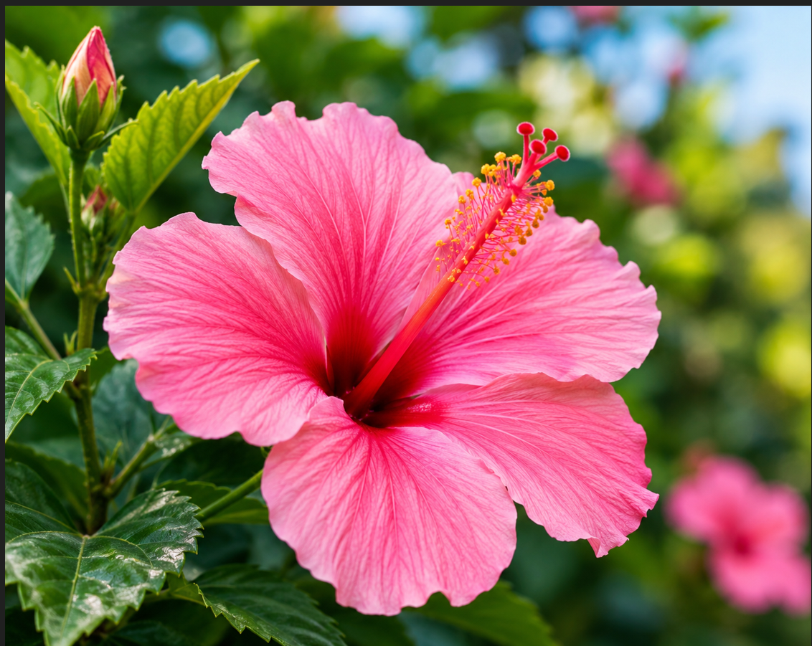

Output:
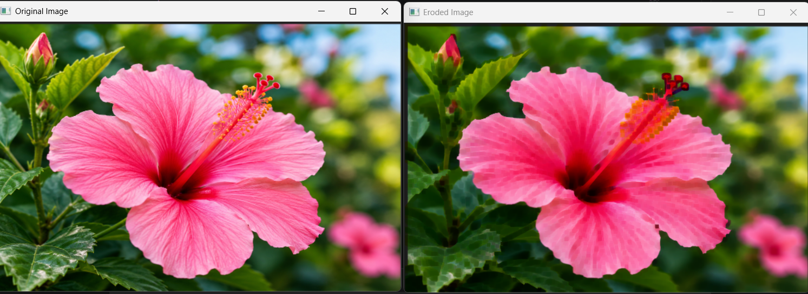
Result:
The image was successfully eroded, and the object boundaries became thinner.

